

- DURBAN
- CAPE TOWN
- JOHANNESBURG

FITTINGS CATALOGUE

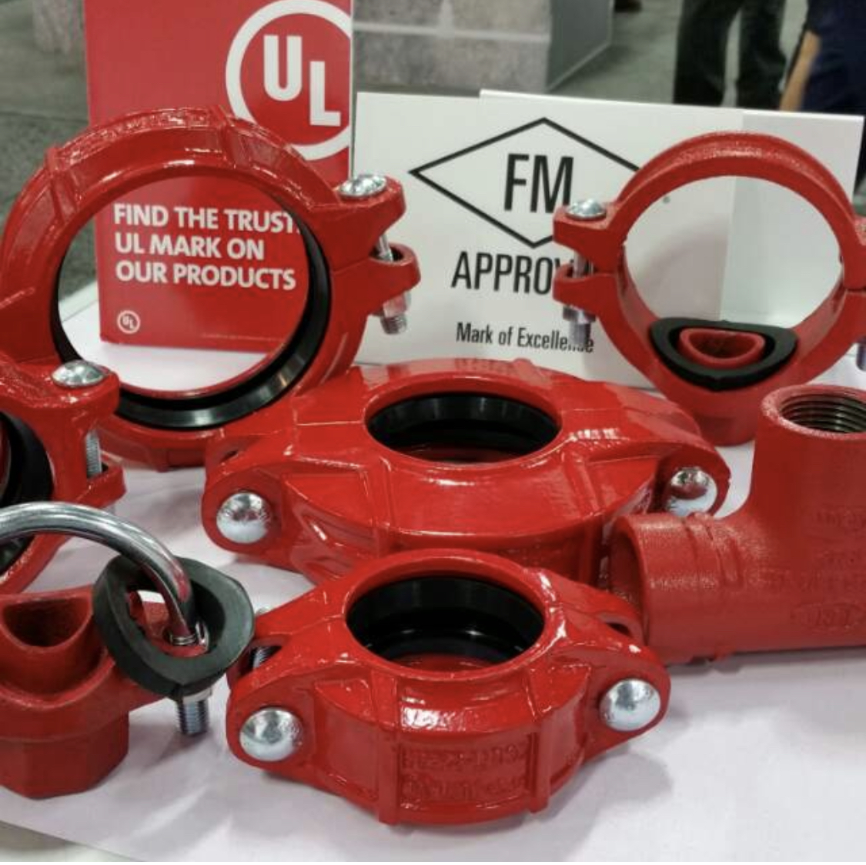

FITTINGS
TYPE AND DIMENSIONS OF FITTING



RIGID COUPLING
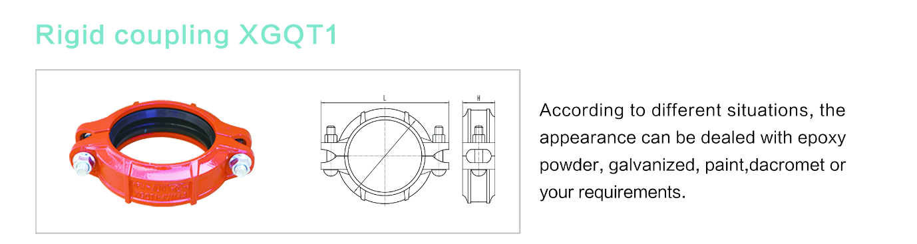

Nominal Size mm/in | Pipe O.D mm/in | Working Pressure Bar/KPA | Bolt Size | Dimensions mm/in
Nominal Size mm/in | Pipe O.D mm/in | Working Pressure Bar/KPA | No. – Size mm | ᶲ | L | H
50  2 | 60.3  2.374 | 20.68  2070 | 2-M10*55 | 88.4  3.480 | 125  4.921 | 46  1.732
65  2 ½ | 76.1  3 | 20.68  2070 | 2-M10*55 | 102.2  4.024 | 140  5.512 | 46  1.772
80  3 | 88.9  3.5 | 20.68  2070 | 2-M10*60 | 117.4  4.622 | 154  6.063 | 46  1.772
100  4 | 114.3  4.25 | 20.68  2070 | 2-M12*65 | 146.6  5.772 | 190  7.480 | 48  1.889
150  6 | 165.1  6.5 | 20.68  2070 | 2-M12*75 | 196.2  7.724 | 244  9.606 | 48  2.008
200  8 | 219.1  8.625 | 15.99  1600 | 2-M16*85 | 256.4  10.024 | 326  12.835 | 58  2.283
250  10 | 273  10.748 | 15.99  1600 | 2-M20*100 | 316  12.441 | 426  16.771 | 64  2.520
300  12 | 323.9  12.75 | 15.99  1600 | 2-M22*130 | 380  14.961 | 470  18.504 | 65  2.559
U-BOLTED MECHANICAL TEE THREADED
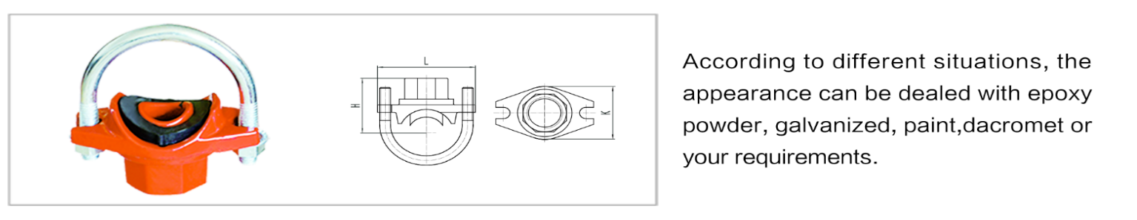

Nominal Size mm/in | Pipe O.D mm/in | Working Pressure Bar/KPA | Bolt Size | Dimensions mm/in |  |  | Hole Cutting  Dimensions
Nominal Size mm/in | Pipe O.D mm/in | Working Pressure Bar/KPA | No. – Size mm | H | L | K | mm/in  +1.6,0/+0.063,0
25 x 15  1 x 1/2 | 33.7 x 21.3  1.327 x 0.839 | 20.68  2070 | M8x25 | 43.5  1.713 | 74  2.913 | 44  1.732 | 26  1.024
32 x 15  1 ¼ x 1/2 | 42.4 x 21.3  1.669 x 0.839 | 20.68  2070 | M10x28.5 | 47  1.850 | 90  2.953 | 69  2.717 | 30  1.181
32 x 20  1 ¼ x 3/4 | 42.4 x 26.9  1.669 x 1.059 | 20.68  2070 | M10x28.5 | 51  2.008 | 90  3.543 | 56  2.205 | 30  1.181
40 x 15  1 ½ x 1/2 | 48.3 x 21.3  1.900 x 0.839 | 20.68  2070 | M10x28.5 | 49  1.929 | 90  3.543 | 56  2.205 | 30  1.181
40 x 20  1 ½ x 3/4 | 48.3 x 26.9  1.900 x 1.059 | 20.68  2070 | M10x28.5 | 53  2.087 | 90  3.543 | 56  2.205 | 30  1.181
50 x 15  2 x 1/2 | 60.3 x 21.3  2.375 x 0.839 | 20.68  2070 | M10x30 | 56  2.205 | 100  3.937 | 56  2.205 | 30  1.181
50 x 20  2 x 3/4 | 60.3 x 26.9  2.375 x 1.059 | 20.68  2070 | M10x30 | 60  2.362 | 100  3.937 | 56  2.205 | 30  1.181

FITTINGS
TYPE AND DIMENSIONS OF FITTING

Nominal Size mm/in | Pipe O.D mm/in | Working Pressure Bar/KPA | Bolt Size | Dimensions mm/in |  |  |  | Hole Dia
Nominal Size mm/in | Pipe O.D mm/in | Working Pressure Bar/KPA | No. – Size mm | ᶲ | L | K | H | mm/in  +1.6,0/+0.063,0
80x50  3x2 | 88.9x60.3  3.50x2.375 | 20.68  2070 | 2-M10x60 | 113  4.449 | 146  5.748 | 80.5  3.169 | 91  3.583 | 61  2.402
100x80  4x3 | 114x88.9  4.50x3.50 | 20.68  2070 | 2-M12x75 | 138  5.433 | 176  6.929 | 93  3.661 | 118  4.545 | 86  3.386
150x100  6x4 | 168.3x114.3  6.625x4.50 | 20.68  2070 | 2-M12x75 | 192  7.559 | 228  8.976 | 120  4.724 | 147  5.787 | 114  4.488
MECHANICAL TEE GROOVED

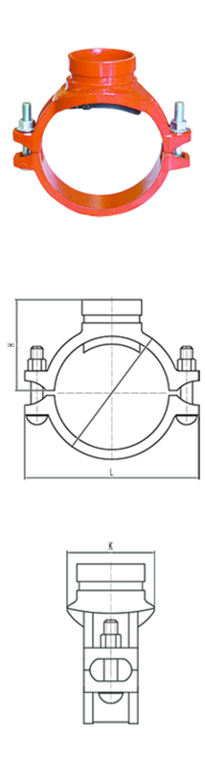

MECHANICAL TEE THREADED

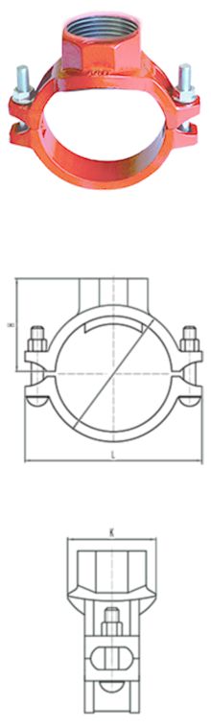
Nominal Size mm/in | Pipe O.D mm/in | Working Pressure Bar/KPA | Bolt Size | Dimensions mm/in |  |  |  | Hole Dia
Nominal Size mm/in | Pipe O.D mm/in | Working Pressure Bar/KPA | No. – Size mm | ᶲ | L | K | H | mm/in  +1.6,0/+0.063,0
80x25  3x1 | 88.9x33.7  3.500x1.327 | 20.68  2070 | 2-M10x60 | 113  4.449 | 146  5.748 | 75  2.953 | 69  2.717 | 38  1.496
80x50  3x2 | 88.9x60.3  3.500x2.375 | 20.68  2070 | 2-M10x60 | 113  4.449 | 146  5.748 | 75  2.953 | 91  3.583 | 61  2.402

TYPE AND DIMENSIONS OF FITTING
FITTINGS

90 ° ELBOW

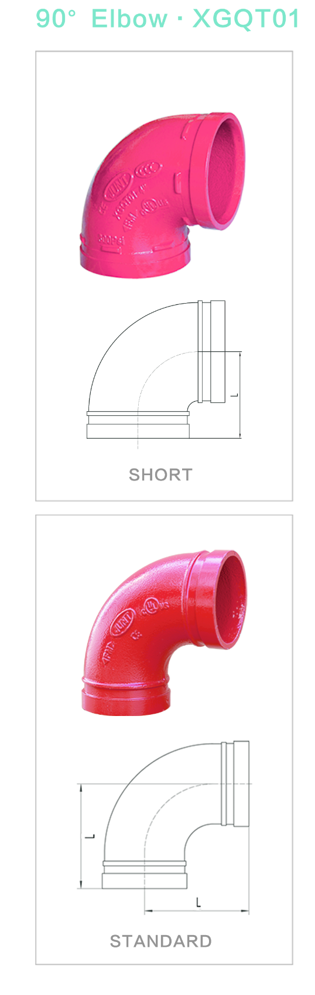
Nominal Size mm/in | Pipe O.D mm/in | Working Pressure Bar/KPA | L mm/in
Nominal Size mm/in | Pipe O.D mm/in | Working Pressure Bar/KPA | Short
50  2 | 60.3  2.375 | 20.68  2070 | 70  2.756
65  2 ½ | 76.1  3 | 20.68  2070 | 76  2.992
80  3 | 88.9  3.5 | 20.68  2070 | 90  3.543
100  4 | 114.3  4.5 | 20.68  2070 | 102  4.016
150  6 | 165.1  6.5 | 20.68  2070 | 140  5.512
200  8 | 219.1  8.625 | 20.68  2070 | 175  6.890
250  10 | 273  10.75 | 20.68  2070 | 215  8.465

Nominal Size mm/in | Pipe O.D mm/in | Working Pressure Bar/KPA | L mm/in
Nominal Size mm/in | Pipe O.D mm/in | Working Pressure Bar/KPA | Standard
50  2 | 60.3  2.375 | 20.68  2070 | 83  3.27
65  2 ½ | 76.1  3 | 20.68  2070 | 95  3.74
80  3 | 88.9  3.5 | 20.68  2070 | 108  4.25
100  4 | 114.3  4.5 | 20.68  2070 | 127  5.00
150  6 | 165.1  6.5 | 20.68  2070 | 165  6.50
200  8 | 219.1  8.625 | 20.68  2070 | 197  7.75
250  10 | 273  10.75 | 20.68  2070 | 229  9.00

TYPE AND DIMENSIONS OF FITTING
FITTINGS

45 ° ELBOW

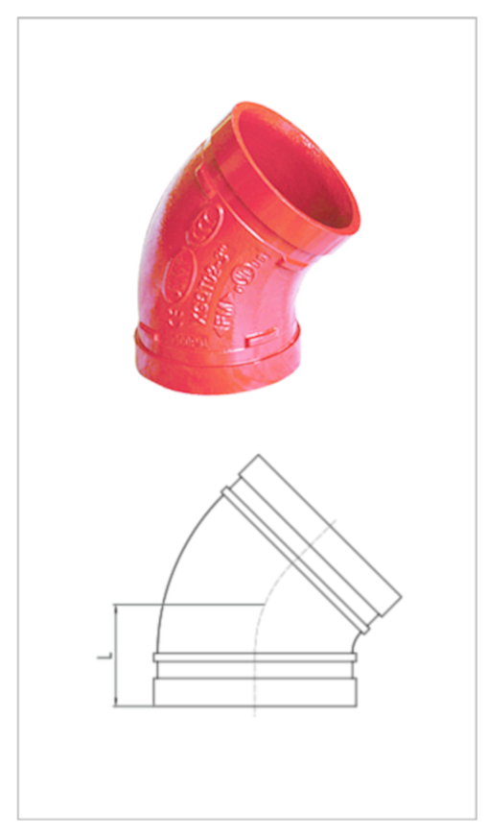
Nominal Size mm/in | Pipe O.D mm/in | Working Pressure Bar/KPA | L mm/in
65  2 ½ | 76.1  3 | 20.68  2070 | 57  2.244
80  3 | 88.9  3.5 | 20.68  2070 | 64  2.52
100  4 | 114.3  4.5 | 20.68  2070 | 76  2.992
150  6 | 165.1  6.5 | 20.68  2070 | 89  3.504
200  8 | 219.1  8.625 | 15.99  1600 | 108  4.252
250  10 | 273  10.75 | 15.99  1600 | 121  4.764

CONCENTRIC REDUCER

Nominal Size mm/in | Pipe O.D mm/in | Working Pressure Bar/KPA | L mm/in
65x50  2 ½ x 2 | 76.1x60.3  2.996x2.375 | 20.68  2070 | 64  2.62
80x65  3x2 ½ | 88.9x76.1  3.5x2.996 | 20.68  2070 | 64  2.52
100x80  4x3 | 114.3x88.9  1.5x3.5 | 20.68  2070 | 76  2.992
150x100  6x4 | 168.3x114.3  6.614x4.5 | 20.68  2070 | 102  4.016
200x150  8x6 | 219.1x165.1  8.626x6.5 | 15.99  1600 | 127  5
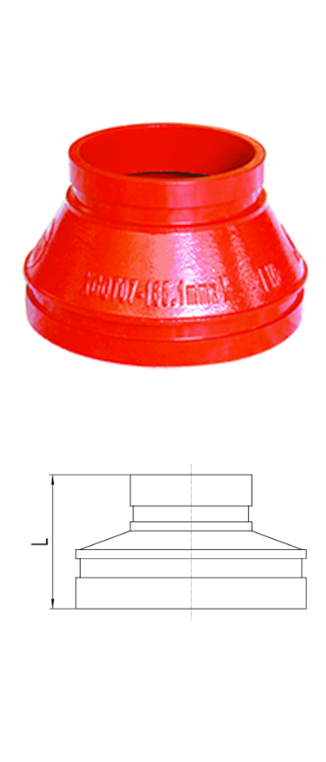

TYPE AND DIMENSIONS OF FITTING
FITTINGS

EQUAL TEE

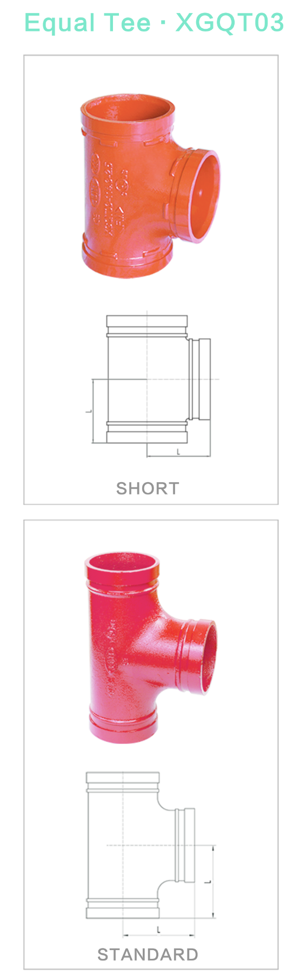
Nominal Size mm/in | Pipe O.D mm/in | Working Pressure Bar/KPA | L mm/in
Nominal Size mm/in | Pipe O.D mm/in | Working Pressure Bar/KPA | Short
50  2 | 60.3  2.375 | 20.68  2070 | 70  2.756
65  2 ½ | 76.1  3 | 20.68  2070 | 76  2.992
80  3 | 88.9  3.5 | 20.68  2070 | 86  3.386
100  4 | 114.3  4.5 | 20.68  2070 | 102  4.016
150  6 | 165.1  6.5 | 20.68  2070 | 140  5.512
200  8 | 219.1  8.625 | 15.99  1600 | 175  6.890
250  10 | 273  10.75 | 15.99  1600 | 215  8.466

Nominal Size mm/in | Pipe O.D mm/in | Working Pressure Bar/KPA | L mm/in
Nominal Size mm/in | Pipe O.D mm/in | Working Pressure Bar/KPA | Standard
50  2 | 60.3  2.375 | 20.68  2070 | 83  3.27
65  2 ½ | 76.1  3 | 20.68  2070 | 95  3.74
80  3 | 88.9  3.5 | 20.68  2070 | 108  4.25
100  4 | 114.3  4.5 | 20.68  2070 | 127  5.00
150  6 | 165.1  6.5 | 20.68  2070 | 165  6.50
200  8 | 219.1  8.625 | 15.99  1600 | 197  7.75
250  10 | 273  10.75 | 15.99  1600 | 229  9.00

TYPE AND DIMENSIONS OF FITTING
FITTINGS

FLANGE ADAPTOR

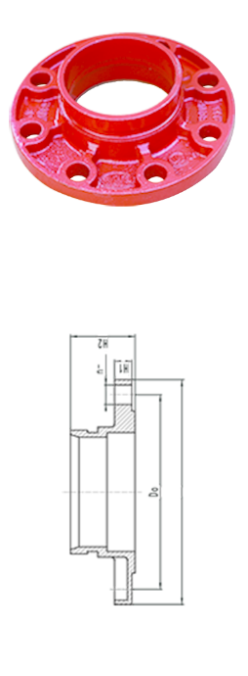
Nominal Size mm/in | Pipe O.D mm/in | Working Pressure Bar/KPA | Dimensions mm/in |  |  |  | Bolt/Nut
Nominal Size mm/in | Pipe O.D mm/in | Working Pressure Bar/KPA | Do | H1 | H2 | ᶲ | No. – Size mm
80  3 | 88.9  3.5 | 15.99  1600 | 160  6.299 | 17  0.669 | 60  2.362 | 195  7.677 | 8xM16
100  4 | 114.3  4.5 | 15.99  1600 | 180  7.087 | 17  0.669 | 60  2.362 | 215  8.465 | 8xM16
150  6 | 165.1  6.5 | 15.99  1600 | 240  9.449 | 20  0.787 | 65  2.559 | 280  11.024 | 8xM20
200  8 | 219.1  8.625 | 15.99  1600 | 295  11.614 | 20.  0.787 | 75  2.952 | 330  12.992 | 12xM20
250  10 | 273  10.748 | 15.99  1600 | 295  11.614 | 25  0.984 | 85  3.346 | 400  15.748 | 12xM20

REDUCING TEE GROOVED

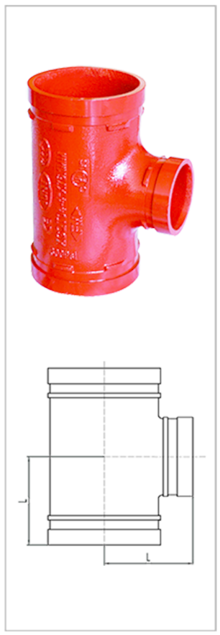

Nominal Size mm/in | Pipe O.D mm/in | Working Pressure Bar/KPA | L mm/in
100x80  4x3 | 108x88.9  4.3x3.5 | 20.68  2070 | 102  4.016
150x100  6x4 | 165.1x114.3  6.5x4.5 | 20.68  2070 | 140  5.512

TYPE AND DIMENSIONS OF FITTING
FITTINGS

CAP

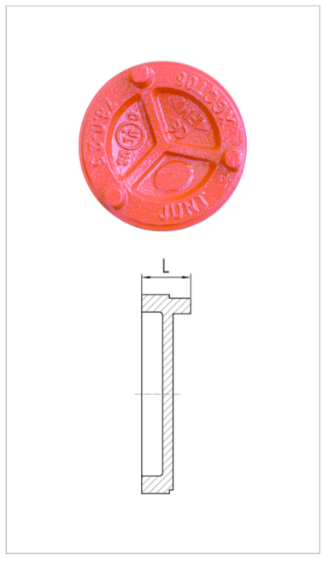
Nominal Size mm/in | Pipe O.D mm/in | Working Pressure Bar/KPA | L mm/in
50  2 | 60.3  2.375 | 20.68  2070 | 26  1.024
65  2 ½ | 76.1  3 | 20.68  2070 | 28  1.102
80  3 | 88.9  3.5 | 20.68  2070 | 28  1.102
100  4 | 114.3  4.5 | 20.68  2070 | 28  1.102
150  6 | 165.1  6.5 | 20.68  2070 | 28  1.102

RIGID COUPLING GALVANISED
GALVANISED
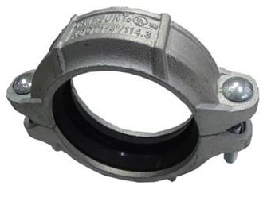

Nominal Size mm/in | Pipe O.D mm/in | Working Pressure Bar/KPA | Bolt Size | Dimensions mm/in
Nominal Size mm/in | Pipe O.D mm/in | Working Pressure Bar/KPA | No. – Size mm | ᶲ | L | H
50  2 | 60.3  2.374 | 20.68  2070 | 2-M10*55 | 88.4  3.480 | 125  4.921 | 46  1.732
65  2 ½ | 76.1  3 | 20.68  2070 | 2-M10*55 | 102.2  4.024 | 140  5.512 | 46  1.772
80  3 | 88.9  3.5 | 20.68  2070 | 2-M10*60 | 117.4  4.622 | 154  6.063 | 46  1.772
100  4 | 114.3  4.25 | 20.68  2070 | 2-M12*65 | 146.6  5.772 | 190  7.480 | 48  1.889
150  6 | 165.1  6.5 | 20.68  2070 | 2-M12*75 | 196.2  7.724 | 244  9.606 | 48  2.008
200  8 | 219.1  8.625 | 15.99  1600 | 2-M16*85 | 256.4  10.024 | 326  12.835 | 58  2.283
250  10 | 273  10.748 | 15.99  1600 | 2-M20*100 | 316  12.441 | 426  16.771 | 64  2.520
300  12 | 323.9  12.75 | 15.99  1600 | 2-M22*130 | 380  14.961 | 470  18.504 | 65  2.559
TYPE AND DIMENSIONS OF FITTING
FITTINGS

90 ° ELBOW GALVANISED

90 ° ELBOW GALVANISED

Nominal Size mm/in | Pipe O.D mm/in | Working Pressure Bar/KPA | L mm/in
Nominal Size mm/in | Pipe O.D mm/in | Working Pressure Bar/KPA | Short
50  2 | 60.3  2.375 | 20.68  2070 | 70  2.756
65  2 ½ | 76.1  3 | 20.68  2070 | 76  2.992
80  3 | 88.9  3.5 | 20.68  2070 | 90  3.543
100  4 | 114.3  4.5 | 20.68  2070 | 102  4.016
150  6 | 165.1  6.5 | 20.68  2070 | 140  5.512
200  8 | 219.1  8.625 | 20.68  2070 | 175  6.890
250  10 | 273  10.75 | 20.68  2070 | 215  8.465
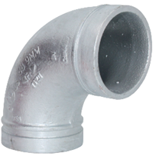

Nominal Size mm/in | Pipe O.D mm/in | Working Pressure Bar/KPA | L mm/in
Nominal Size mm/in | Pipe O.D mm/in | Working Pressure Bar/KPA | Standard
50  2 | 60.3  2.375 | 20.68  2070 | 83  3.27
65  2 ½ | 76.1  3 | 20.68  2070 | 95  3.74
80  3 | 88.9  3.5 | 20.68  2070 | 108  4.25
100  4 | 114.3  4.5 | 20.68  2070 | 127  5.00
150  6 | 165.1  6.5 | 20.68  2070 | 165  6.50
200  8 | 219.1  8.625 | 20.68  2070 | 197  7.75
250  10 | 273  10.75 | 20.68  2070 | 229  9.00

TYPE AND DIMENSIONS OF FITTING
FITTINGS

EQUAL TEE GALVANISED
GALVANISED

Nominal Size mm/in | Pipe O.D mm/in | Working Pressure Bar/KPA | L mm/in
Nominal Size mm/in | Pipe O.D mm/in | Working Pressure Bar/KPA | Short
50  2 | 60.3  2.375 | 20.68  2070 | 70  2.756
65  2 ½ | 76.1  3 | 20.68  2070 | 76  2.992
80  3 | 88.9  3.5 | 20.68  2070 | 86  3.386
100  4 | 114.3  4.5 | 20.68  2070 | 102  4.016
150  6 | 165.1  6.5 | 20.68  2070 | 140  5.512
200  8 | 219.1  8.625 | 15.99  1600 | 175  6.890
250  10 | 273  10.75 | 15.99  1600 | 215  8.466
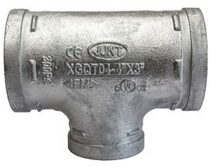

Nominal Size mm/in | Pipe O.D mm/in | Working Pressure Bar/KPA | L mm/in
Nominal Size mm/in | Pipe O.D mm/in | Working Pressure Bar/KPA | Standard
50  2 | 60.3  2.375 | 20.68  2070 | 83  3.27
65  2 ½ | 76.1  3 | 20.68  2070 | 95  3.74
80  3 | 88.9  3.5 | 20.68  2070 | 108  4.25
100  4 | 114.3  4.5 | 20.68  2070 | 127  5.00
150  6 | 165.1  6.5 | 20.68  2070 | 165  6.50
200  8 | 219.1  8.625 | 15.99  1600 | 197  7.75

TYPE AND DIMENSIONS OF FITTING
FITTINGS

P CLIPS

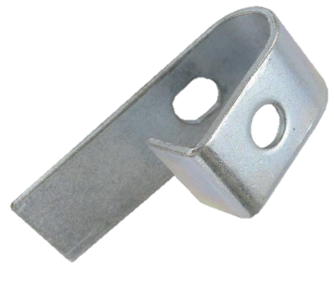
P Clip Size
mm
M 8 | M 12

PIPE HANGER

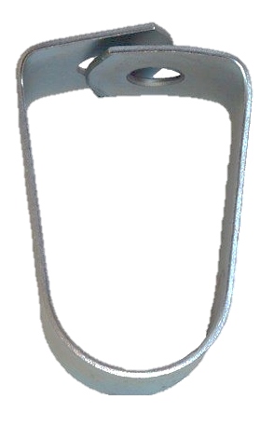

Pipe Hanger Size
mm
25 | 32 | 40 | 50 | 65 | 80 | 100 | 150

